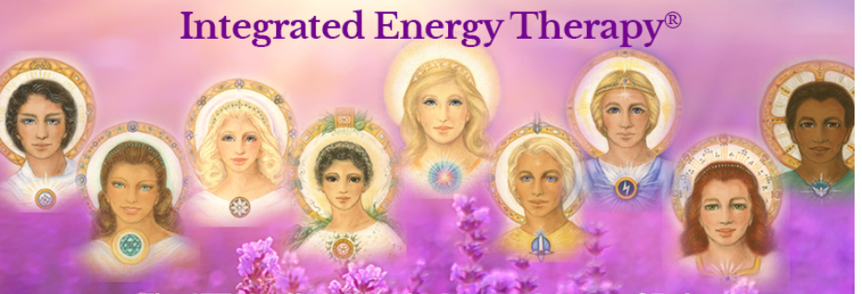

You can meet and work with The
INTEGRATED ENERGY THERAPY® (iet) Healing Angels
Ariel, Raphael, Gabriel, Celestina, Faith,
Cassiel, Daniel, Sarah, and Michael

A special IET workshop with jEAN

Date: april 4th
Time: 9:30 AM – 5:30 PM
Location: Huna Healing center
Fee: $110
Note: you receive a copy of our special illustrated Healing Angels of the Energy Field Class Workbook as part of this class.

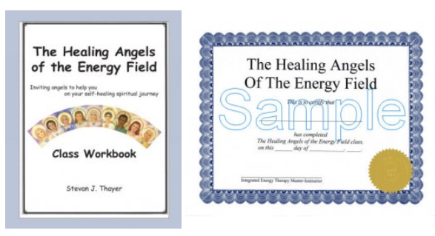

This course was created to help you discover the special healing gifts that each of these Healing Angels bring. You will learn how to invite each of these healing angels to support you in your physical, emotional, mental and spiritual healing journey.
You will learn special prayers of invitation that will enable you to call upon these Healing Angels whenever you need healing support. In addition, if you support others in their self-healing through energy therapies like Integrated Energy Therapy, Reiki, Therapeutic Touch, Healing Touch, Massage or other techniques, the Healing Angels can add a special spiritual dimension to your sessions.
In this class you will learn how to use an Angelic Heartlink to connect with each angels’ energy. Then, through the power of the group's energy, you will have the ideal opportunity to establish and strengthen your personal connection with each of the IET Healing Angels of the Energy Field, and directly experience each angel in the way that is perfect for you.

Make the Healing Angels part of your healing journey today and meet nine amazing angels by registering at the Huna Healing Center or
visit https://sparklewithangels.com/IET_Healing_Angels_Class.html for more info.

